stp & etherchannel TUNNING pROJECT

A portfolio project by ABDUSSAMAD ALHASSAN

[**LinkedIn**](http://www.linkedin.com/in/abdussamad-alhassan) Profile

x.com/grndmaster_

Table of Contents

Tables 3

Executive Summary 4

1.1 Design Objectives 4

1.2 Network Components 4

1.3 Implementation Overview 4

Network Topology 5

2.1 Topology Diagram 5

2.1.1 Physical Topology 5

2.1.2 Logical Topology 5

2.2 Core Network Components 6

2.2.1 Core Switches (SW1, SW2, SW3) 6

2.2.2 Routers (R1 and R2): 6

2.2.3 Virtual Private Clouds (VPCs) 6

2.3 Interconnectivity 6

2.3.1 Layer 2 Connectivity 6

2.3.2 Trunking 6

2.4 High Availability and Redundancy 7

2.5 Security and Management 7

2.6 DHCP Management 7

Device Inventory 8

2.1 Core Switches 8

2.2 Routers 8

2.3 Virtual PC Simulator (VPC) 8

2.4 Summary of Interface Configurations and Connections 9

Network Configurations 11

4.1 Global Configuration 11

4.2 Device Configurations 11

4.2.1 Router 1 (R1) Configuration 11

4.2.2 Router 2 (R2) Configuration: 12

4.2.3 Access Switch (SW1) Configuration: 12

4.2.4 Access Switch (SW2) Configuration: 12

4.2.5 Access Switch (SW3) Configuration 12

4.3 IP Address Schema 12

4.4 VLAN Configuration 13

4.5 High Availability and Redundancy 13

Routing and Switching Design 14

5.1 Layered Network Design 14

5.2 Routing Design 14

5.3 Switching Design 15

5.4 Redundancy and High Availability 15

Network Performance and Optimization 16

6.1 Key Optimization Techniques 16

Conclusion 17

# Tables

Table 1. Core Switches table 6

Table 2 Routers Table 6

Table 3 VPCs 7

# Executive Summary

This document outlines the design and implementation of a robust networking solution for a simulated enterprise environment, aimed at showcasing my technical expertise and practical skills in network engineering. The network is structured around three core components: core switches (SW1, SW2, and SW3), routers (R1 and R2), and Virtual Private Clouds (VPCs) equipped with DHCP services to facilitate dynamic IP address allocation.

## 1.1 Design Objectives

The primary objective of this networking project is to create a highly available and scalable infrastructure that ensures seamless connectivity across multiple branches while implementing redundancy protocols to enhance network reliability. The configuration leverages industry best practices, including:

1. Layer 2 Switching: Utilizing VLANs and Port Channels to optimize traffic flow and improve network performance.
2. First Hop Redundancy Protocol (FHRP): Implementing GLBP (Gateway Load Balancing Protocol) on routers R1 and R2 to ensure high availability and load balancing for IP address allocation.
3. Dynamic Host Configuration Protocol (DHCP): Enabling DHCP on VPCs 4, 5, and 6 to simplify IP address management and improve network efficiency.

## 1.2 Network Components

1. Core SwitchesConfigured to support trunking and VLAN segmentation for effective traffic management across different network segments.
2. Routers (R1 and R2): These devices serve as the gateway for internal traffic to external networks, equipped with GLBP for enhanced fault tolerance.
3. Virtual Private Clouds (VPCs): Each VPC is configured with DHCP to provide dynamic IP address allocation for connected devices, improving usability and minimizing administrative overhead.

## 1.3 Implementation Overview

The network infrastructure is configured using Cisco IOS, showcasing the following features:

1. Redundant Paths: By implementing GLBP and Port Channels, the network can maintain uptime and performance even during hardware failures.
2. IP Address Management: The DHCP configurations streamline the process of assigning IP addresses, ensuring efficient utilization of available address space.
3. Security Measures: Standard security practices have been applied, including disabling unused ports and ensuring appropriate access controls.

# Network Topology

This section details the network topology implemented for the simulated enterprise environment. The design is structured to optimize performance, reliability, and scalability while ensuring effective communication between different network segments.

## 2.1 Topology Diagram

### 2.1.1 Physical Topology

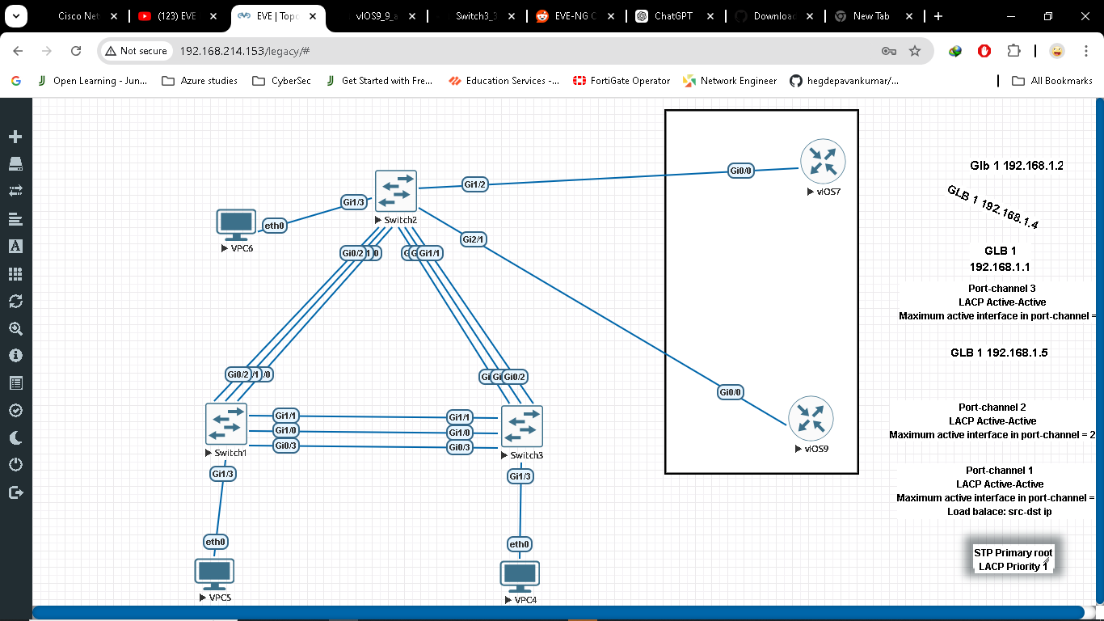

Figure 1 Physical topology

### 2.1.2 Logical Topology

Logical Topology focuses on how devices communicate with each other, the protocols used, and the logical connections between devices, including link aggregation technologies like EtherChannel for redundancy and spanning tree for loop prevention. It illustrates the logical flow of data and the relationships between network components.

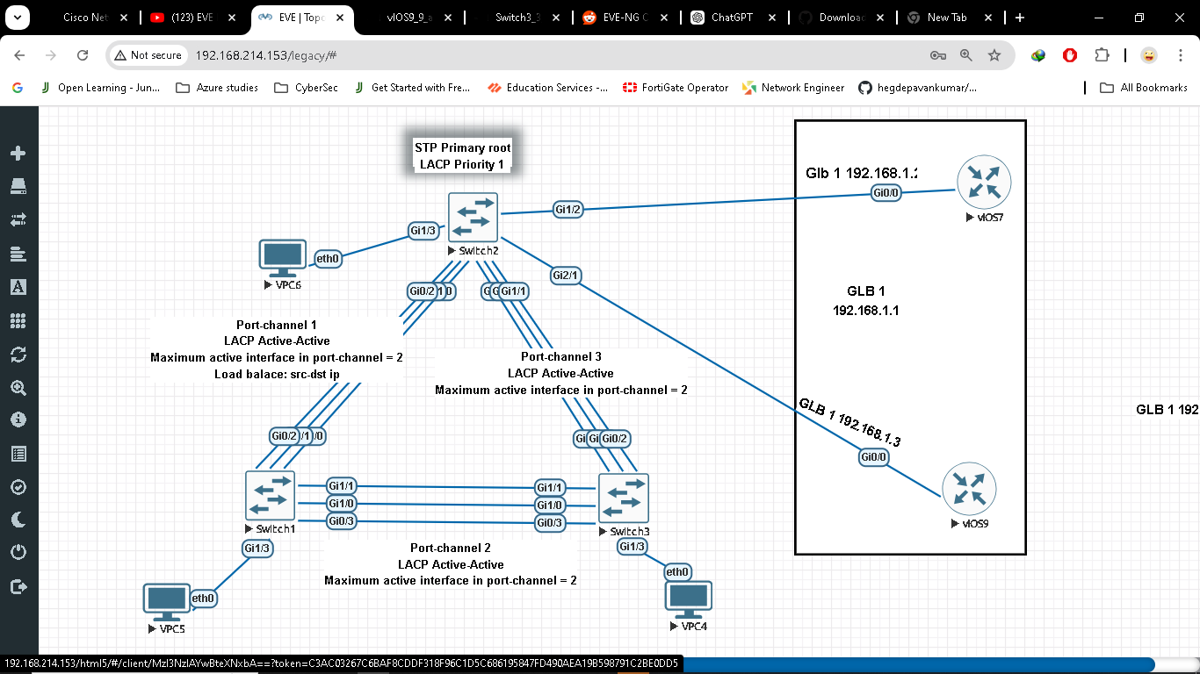

Figure 2. Logical Topology

## 2.2 Core Network Components

2.2.1 Core Switches (SW1, SW2, SW3):

* These switches form the backbone of the network, facilitating high-speed connectivity between various segments.
* They support VLAN segmentation, enhancing traffic management and security.

### 2.2.2 Routers (R1 and R2):

* Responsible for routing traffic between different VLANs and external networks.
* Configured with Gateway Load Balancing Protocol (GLBP) to provide redundancy and load balancing for IP address allocation.

### 2.2.3 Virtual Private Clouds (VPCs)

VPCs 4, 5, and 6:

* Each VPC is equipped with DHCP services to dynamically allocate IP addresses to connected devices.
* They provide isolated environments for testing and development purposes.

## 2.3 Interconnectivity

### 2.3.1 Layer 2 Connectivity

Port Channels are configured on the core switches, allowing multiple physical links to be aggregated into a single logical link, improving bandwidth and providing redundancy.

### 2.3.2 Trunking

VLANs are extended across the switches using trunking protocols (802.1Q), allowing for the transmission of traffic from multiple VLANs over a single physical link.

## 2.4 High Availability and Redundancy

First Hop Redundancy Protocol (FHRP)

GLBP is implemented between routers R1 and R2, ensuring that in the event of a failure, network traffic can be seamlessly rerouted, maintaining uninterrupted connectivity.

## 2.5 Security and Management

Access Control:

Unused switch ports are disabled to prevent unauthorized access and enhance network security.

## 2.6 DHCP Management

The DHCP configuration on VPCs streamlines IP address management, minimizing the potential for conflicts and ensuring efficient utilization of the address space.

# Device Inventory

The following section outlines the devices deployed in the network topology, including their specifications, roles, and configurations. This inventory provides a comprehensive overview of the hardware and software resources utilized within the network environment for portfolio practice.

## 2.1 Core Switches

Table 1. Core Switches table

|  |  |  |  |
| --- | --- | --- | --- |
| Device Name | Model | Role | Configuration Highlights |
| SW1 | Cisco Catalyst 9300 | Core Switch | Supports VLANs, Port Channels, and STP configurations. | |
| SW2 | Cisco Catalyst 9300 | Core Switch | Spanning tree primary root  LACP System priority 1  Acts as an aggregation point for downstream devices and implements redundancy. |
| SW3 | Cisco Catalyst 9300 | Core Switch | Configured for trunking, VLAN management, and Port Channels |

## 2.2 Routers

|  |  |  |  |
| --- | --- | --- | --- |
| Device Name | Model | Role | Configuration Highlights |
| vIOS9(R1 ) | Cisco ISR 4000 | Primary Router | Configured with GLBP for redundancy, DHCP server, and IP routing. |
| vIOS7 (R2) | Cisco ISR 4000 | Secondary Router | Configured with GLBP and IP routing, supporting failover scenarios |

Table 2 Routers Table

## 2.3 Virtual PC Simulator (VPC)

|  |  |  |
| --- | --- | --- |
| Device Name | Model | Configuration Highlights |
| VPC 4 | DHCP-enabled VPC | Dynamic IP address allocation for connected devices. |
| SW2 | DHCP-enabled VPC | Provides an isolated environment for testing and development |
| SW3 | DHCP-enabled VPC | Supports dynamic IP addressing and VPC segmentation. |

Table 3 VPCs

## 2.4 Summary of Interface Configurations and Connections

|  |  |  |  |  |
| --- | --- | --- | --- | --- |
| Device Name | Interface Name | Configuration details | Connected to | Notes |
| SW1 | Port channel 1  (G0/0-2) | LACP active mode.  Maximum active interfaces in channel:2.  Trunk Mode  Allowed vlans 1-20. | SW2 Port channel 1(G0/0-2) | Aggregates connections from access switches. |
| SW1 | Port channel 2  (G1/0-1, G0/3) | LACP active mode.  Maximum active interfaces in channel:2.  Trunk Mode  Allowed vlans 1-20 | SW3 Port channel 2 (G1/0-1, G0/3) | Aggregates connections from access switches |
| SW2 | Port channel 1  (G0/0-2) | LACP active mode.  Maximum active interfaces in channel:2.  Trunk Mode  Allowed vlans 1-20 | SW1 Portchannel 1 (G0/0-2) | Aggregates connections from access switches |
| SW2 | Port-channel 3  (G1/0-1, G0/3) | LACP active mode.  Maximum active interfaces in channel:2.  Trunk Mode  Allowed vlans 1-20 | SW3 Port-channel 3  (G0/0-2) | Aggregates connections from access switches |
| SW3 | SW3 Port channel 2 (G1/0-1, G0/3) | LACP active mode.  Maximum active interfaces in channel:2.  Trunk Mode  Allowed vlans 1-20 | SW 2 Port-channel 3  (G1/0-1, G0/3) | Aggregates connections from access switches |
| SW3 | Port-channel 3  (G0/0-2) | Maximum active interfaces in channel:2.  Trunk Mode  Allowed vlans 1-20 | Port-channel 3  (G1/0-1, G0/3) | Aggregates connections from access switches |
| vIOS9(R1) | GigabitEthernet0/0 | GLBP configured,  Interface IP 192.168.1.3 | SW2 GigabitEthernet1/2 | Provides redundancy with GLBP |
| vIOS7(R2) | GigabitEthernet0/0 | GLBP configured,  Interface IP 192.168.1.2 | SW2 GigabitEthernet2/1 | Provides redundancy with GLBP |

# Network Configurations

This section provides detailed configuration information for the devices in the network. It covers key settings applied to the routers, switches, and firewalls, as well as routing and redundancy protocols used to ensure high availability, optimal traffic flow, and device security.

## 4.1 Global Configuration

This section includes global configurations applied to devices across the network, such as routing protocols, VLANs, and system management settings.

* **Routing Protocols**:
* **Spanning Tree Protocol**:
  + Configured **Rapid PVST+ (Per-VLAN Spanning Tree Plus)** on all switches to prevent broadcast storms and provide Layer 2 loop prevention.
* **DHCP Configuration**:
  + DHCP is enabled on **R1** to allocate IP addresses dynamically within the 192.168.1.0/24 network. Excluded addresses range from 192.168.1.1 to 192.168.1.19 to reserve IPs for network devices.
* **Link Aggregation**:
  + EtherChannels are configured using **LACP (Link Aggregation Control Protocol)** to bundle multiple physical links, increasing bandwidth and providing redundancy.
* **First Hop Redundancy**
  + **GLBP (Gateway Load Balancing Protocol)** is configured on routers R1 and R2 to provide gateway redundancy and load balancing.

## 4.2 Device Configurations

The following are the key configuration elements for each device:

4.2.1 Router 1 (R1) Configuration:

* Hostname**: R1**
* **I**nterface**s**:
  + GigabitEthernet0/0: Configured with IP address 192.168.1.3/24, connected to SW3.
  + GLBP Group 1: Virtual IP address 192.168.1.1 with priority 200, default gateway for clients.
* DHCP Server:
  + DHCP pool named network.
  + default-router set to 192.168.1.1.
  + domain-name set to ccna.com.
  + Lease time: 2 days.

### 4.2.2 Router 2 (R2) Configuration:

* **Hostname**: R2
* Interfaces:
  + GigabitEthernet0/0: Configured with IP address 192.168.1.2/24, connected to SW3.
  + GLBP Group 1: Virtual IP address 192.168.1.1 with priority 100, backup default gateway for clients.

### 4.2.3 Access Switch (SW1) Configuration:

* Hostname: SW1
* Interfaces:
  + GigabitEthernet0/1: Trunk port, connected to SW3, part of Port-channel2.
  + VLAN assignment based on department-specific segments.

### 4.2.4 Access Switch (SW2) Configuration:

* Hostname: SW2
* Interfaces:
  + GigabitEthernet0/2: Trunk port, connected to SW3, part of Port-channel3.
  + VLAN assignment based on department-specific segments.
* VLAN Configuration:
  + VLANs 1-20 created and assigned as required to ports

4.2.5 Access Switch (SW3) Configuration:

* Hostname: SW3
* Interfaces:
  + Port-channel2: Trunk link to SW1, configured with VLANs 1-20.
  + Port-channel3: Trunk link to SW2, configured with VLANs 1-20.
* VLAN Configuration:
  + VLANs 1-20 created and assigned as required to ports.
* EtherChannel Configuration:
  + LACP used for port channels to aggregate links for redundancy and load balancing.

## 4.3 IP Address Schema

A concise list of IP address assignments for all interfaces:

* **Router 1 (R1)**:
  + GigabitEthernet0/0: 192.168.1.3/24
* **Router 2 (R2)**:
  + GigabitEthernet0/0: 192.168.1.2/24
* **Core Switch (SW3)**:
  + VLAN 1 IP address: 192.168.1.4/24 (Management VLAN)
* **Access Switches**:
  + SW1: VLAN 1 IP address: 192.168.1.5/24
  + SW2: VLAN 1 IP address: 192.168.1.6/24

## 4.4 VLAN Configuration

* **VLAN 1**: Management VLAN, IP addressing for device management.
* **VLAN 10-20**: Department-specific VLANs for segmentation and traffic control.
* **VLAN Trunks**: Configured between SW3, SW1, and SW2, as well as router sub-interfaces.

## 4.5 High Availability and Redundancy

* **GLBP** is configured on R1 and R2 to provide first-hop redundancy, allowing both routers to share the same virtual IP for gateway functionality.
* **EtherChannel** configured on SW3 with multiple downstream switches ensures link redundancy and aggregated bandwidth.

# Routing and Switching Design

This section outlines the routing and switching design for the network, focusing on the use of static routing and VLAN segmentation to manage traffic flow effectively.

## 5.1 Layered Network Design

The network is structured using a **flat two-tier design** consisting of a **Core** and **Access Layer** to simplify connectivity and traffic management. This design is appropriate for a portfolio practice network that prioritizes simplicity and effective routing without the need for dynamic protocols.

* **Core Layer**: The core layer is designed to aggregate connections from the access switches and route traffic to the appropriate routers.
  + **Device**: Core Switch (SW2)
  + **Function**: Serves as the aggregation point for all access switches and provides Layer 2 switching capabilities for connected VLANs. It also connects to both R1 and R2 for redundancy.
* **Access Layer**: This layer connects various end-user devices, providing VLAN segmentation for different types of network traffic.
  + **Devices**: Access Switches (SW1, SW3, etc.)
  + **Function**: Provides connectivity for VLANs and trunks up to the core switch (SW2).

## 5.2 Routing Design

The network uses **static routing** to define explicit paths between the routers and the core switch. This approach is ideal for small-scale networks where route changes are infrequent.

* **Static Routing**:
  + **R1** and **R2** are configured with static routes pointing towards internal networks managed by the core switch (SW2).
  + Static routes simplify traffic management and provide predictable routing behavior.
* **Gateway Load Balancing**:
  + **Gateway Load Balancing Protocol (GLBP)** is implemented between R1 and R2 to provide redundancy and load balancing for the default gateway.
  + The virtual IP address 192.168.1.1 is used as the default gateway for devices in the network.
  + R1 and R2 share the gateway load, ensuring efficient distribution of traffic.
* **Route Failover**:
  + In case R1 fails, R2 will automatically take over the forwarding role, maintaining network continuity.

## 5.3 Switching Design

The switching design utilizes VLANs to segment the network and EtherChannel to bundle multiple links, providing higher bandwidth and redundancy.

* **VLAN Design**:
  + VLANs are used to create logical groupings of devices. While the VLANs are not named, they are used to segment traffic for different departments or purposes.
  + **VLANs 1-20** are allowed on the trunk links between the core switch (SW2) and the access switches.
  + **VLAN 1** serves as the native VLAN, while other VLANs (e.g., VLAN 10, 11, etc.) are used for end-device connections.
* **Trunk Configuration**:
  + Trunks between the core switch and the access switches allow multiple VLANs to pass through, ensuring seamless communication between devices on different VLANs.
  + VLANs 1-20 are permitted on all trunk links, providing flexibility for future expansions.
* **EtherChannel Implementation**:
  + **EtherChannel** is configured between the core switch and access switches to bundle multiple physical links into a single logical link.
  + This configuration increases bandwidth and provides redundancy, as the failure of one link does not disrupt communication.

## 5.4 Redundancy and High Availability

The network is designed to provide high availability and redundancy through the use of GLBP and EtherChannel:

* **GLBP for Gateway Redundancy**: Distributes traffic between R1 and R2, ensuring continuous network availability even if one router becomes unavailable.
* **EtherChannel for Link Redundancy**: Bundles multiple links to prevent single points of failure between switches.
* **Static Routing Failover**: In the event of a router failure, static routing configurations ensure that traffic is rerouted through the available router.

# Network Performance and Optimization

The network configuration was designed with redundancy and performance in mind. EtherChannel was implemented between the core switch (SW3) and distribution switches, providing increased bandwidth and fault tolerance. By bundling multiple physical links into logical Port Channels, the network can handle higher traffic loads and provide resilience in case of individual link failures.

## 6.1 Key Optimization Techniques

1. **EtherChannel Bundling:**
   * Implemented EtherChannel with LACP mode on relevant switch ports to bundle multiple physical interfaces, thereby increasing aggregate bandwidth and providing link redundancy.
2. **Load Balancing:**
   * The use of GLBP between the routers (R1 and R2) ensures that traffic is balanced, preventing any single router from becoming a bottleneck.
3. **VLAN Segmentation:**
   * Even though no VLAN names were assigned, VLAN segmentation ensures that traffic within the network is logically separated, minimizing broadcast traffic and optimizing performance.
4. **Spanning Tree Protocol (STP) Optimization:**
   * STP settings, such as priority adjustments, were used to influence the election of the root bridge, ensuring efficient path selection and preventing network loops.

# Conclusion

This network design and implementation document serves as a comprehensive representation of a portfolio practice network that incorporates essential concepts of routing, switching, redundancy, and optimization. The design is structured to highlight fundamental networking principles and demonstrates an understanding of building robust and scalable networks using industry-standard practices.

Key configurations, such as GLBP for gateway redundancy and EtherChannel for link aggregation, provide enhanced performance and resilience, ensuring that the network can handle traffic efficiently while maintaining stability during link failures. Although no advanced security features or dynamic routing protocols were implemented, the network topology and configuration reflect a solid foundational setup that can be extended or adapted as needed.

This network design showcases my ability to design, configure, and optimize complex networks using Cisco devices and industry-best practices, making it a valuable addition to my portfolio as I continue to develop and refine my network engineering skills.